

Student Details
- Student Name: Maxwell Ochieng
- Admission Number: BSCCS/2024/57259
- Course/Class: Bachelor of Science in Computer Science
- Unit Code: BIT320I
- Unit Name: Advanced Web Design
- Lecturer Name: Nyoro Michael
- Semester: Semester 2 , 2024/2025

Project Details
Project Title: Student Management System
Selected Technologies: Nodes.js ,Express.js ,MySQL ,EJS,JWT Authentication ,Bootstrap 5
Online Portfolio /GitHub Link GitHub Repository:
https://github.com/msarlie/maxixello001.git

Page 2: Table of contents
Introduction

  - Project Overview
  - Technology Stack
  - Online Portfolio/GitHub Repository

2. Week 1: Local Environment Setup
2.1 Installation of Node.js and Visual Studio Code
2.2 Database Management System Setup (MySQL/phpMyAdmin)

3. Week 2-4: Core Development (Authentication & Database Design)
3.1 Database Schema Design
3.2 User Authentication Implementation (JWT)

4. Week 5: CRUD Functionality Implementation
4.1 "Add Book" Feature (Create)
4.2 Catalog Display (Read)
4.3 Delete Functionality with Confirmation Prompt
4.4 User-Specific Data Filtering using user id
4.5 Complete System Workflow

5. Student Reflection
5.1 Summary of Week 5 Achievements
5.2 Challenges and Solutions
________________________________________
Week 1: Local Environment Setup
Title: Installation and Testing of Local Development Environment
Required Evidence
Fig 1: Installation of Node.js and Visual Studio Code
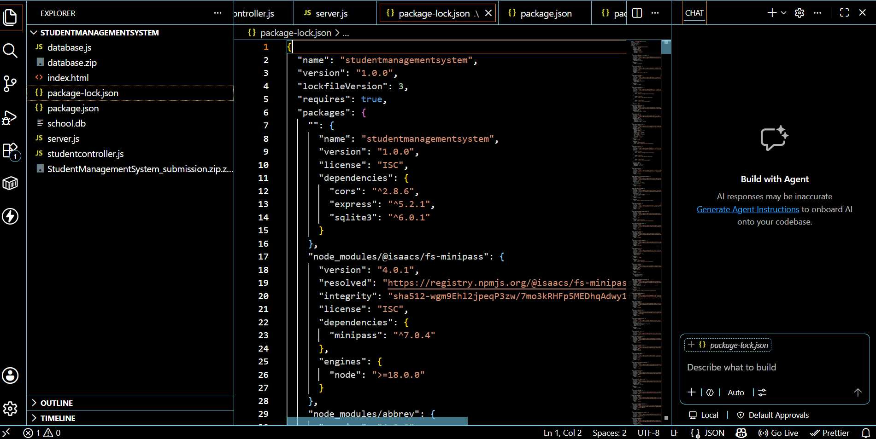
Fig 2: XAMPP Control Panel showing Apache and MySQL running

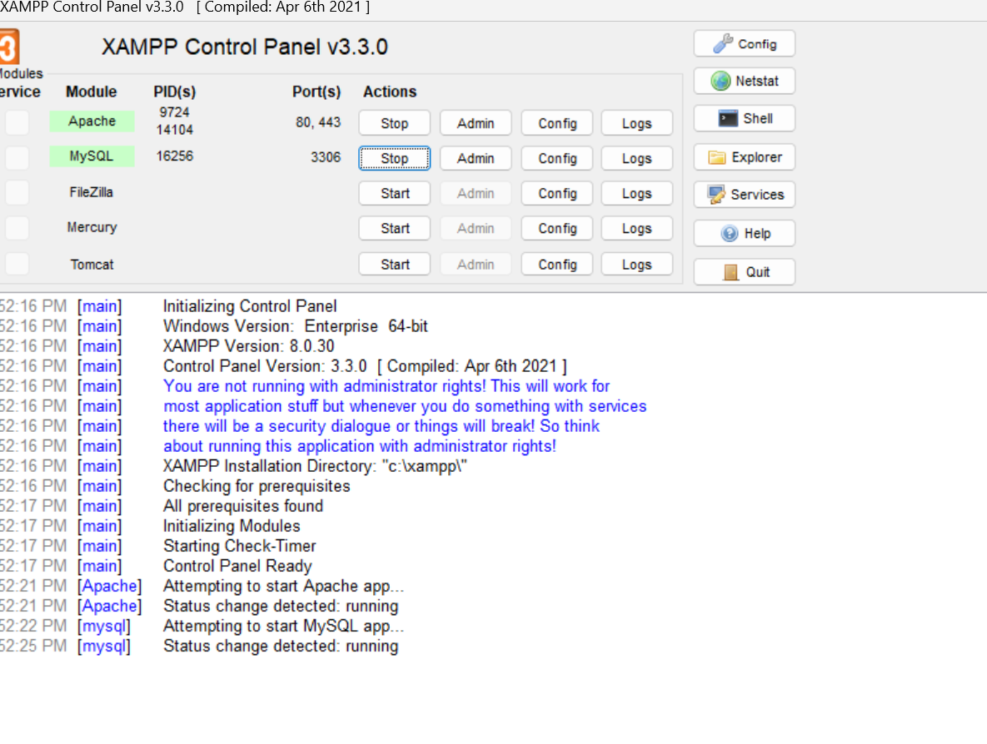
Fig 3: Localhost Test Page
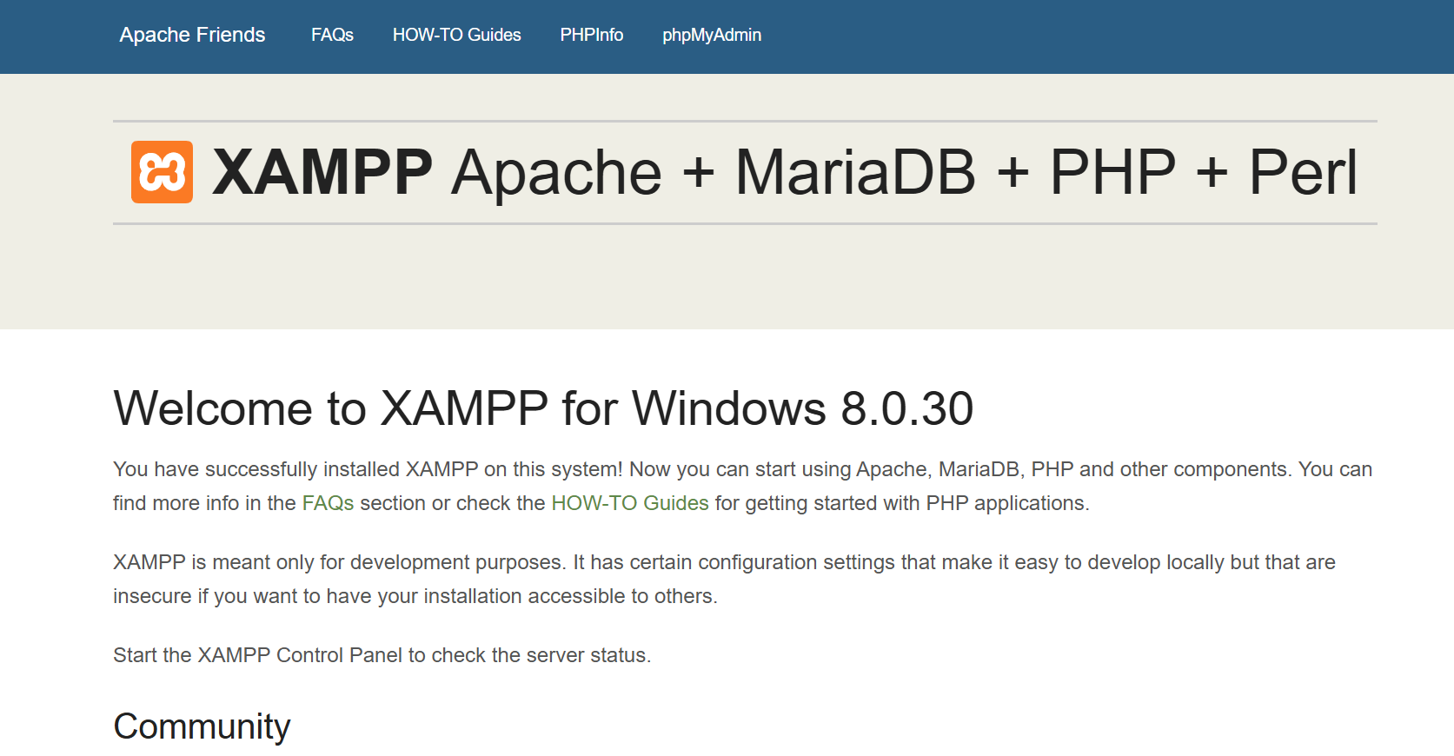
Fig 4: Hello World Test
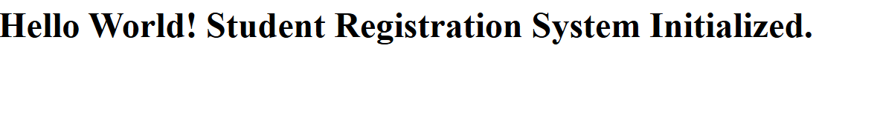
Fig 5: Database Connection Test
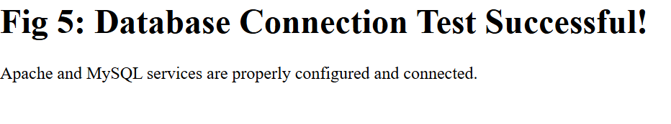
Student Reflection (Maximum 100 words)
Successfully testing the database connection was a critical milestone in establishing the system's backend infrastructure. By utilizing PHP's MySQL extension, I verified that the local Apache server could communicate seamlessly with the MySQL database. Resolving configuration paths and syntax errors during this phase highlighted the importance of clean code and precise environment setup. This successful test ensures that the application is fully prepared to securely handle, store, and retrieve student records in the subsequent phases of development.

Week 2: Wireframes and GUI Design
Title
Fig 1: Hand-drawn Wireframe
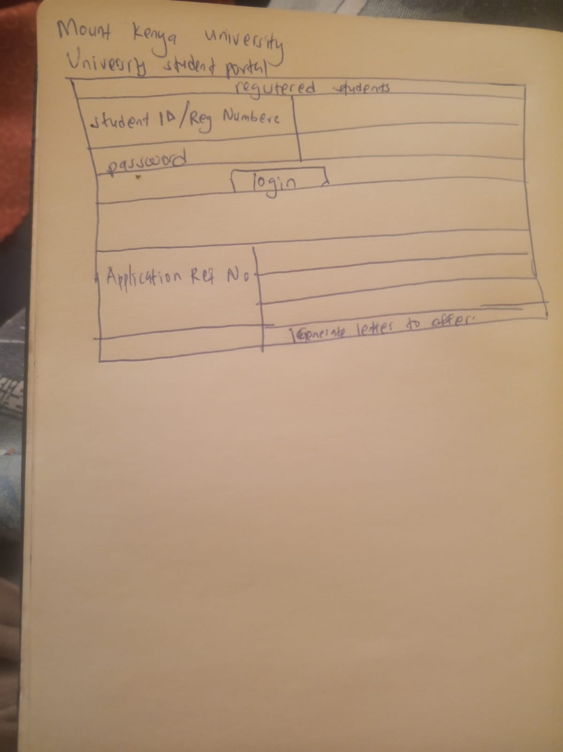
Fig 2: Dashboard Layout Design
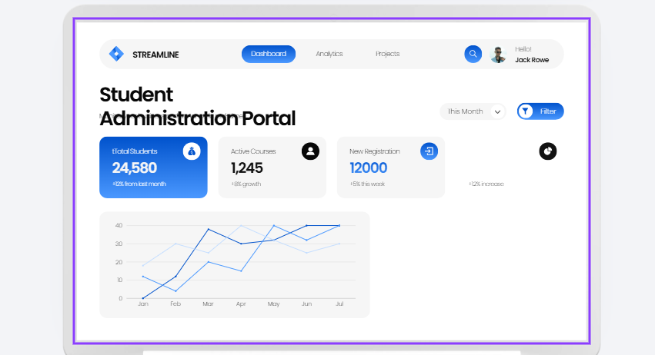

Fig 3: Mobile View Mockup
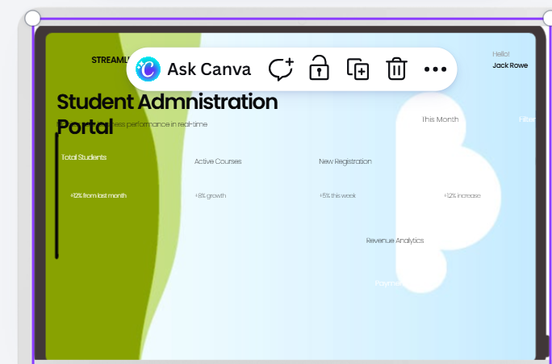
I developed a responsive mobile mockup for the Student Registration System to demonstrate how the interface adapts to smaller smartphone viewports. I prioritized a single-column stacked hierarchy inside a smartphone mockup frame, ensuring essential student metrics remain accessible on the move. My primary challenge was condensing the extensive multi-panel desktop layouts without stripping core system.

Week 3: Backend Developments and Database Integration
Title: Server Setup and MySQL Database Connection
During this week, I focused on the student management system. I established
the connection between my PHP application and the MySQL database, ensuring that the
system could successfully communicate with the server. This phase involved configuring the
main.py file to handle database queries and troubleshooting initial connection issues, such
as ensuring the database name in my code matched the one created in phpMyAdmin, to
allow for seamless data retrieval and storage.
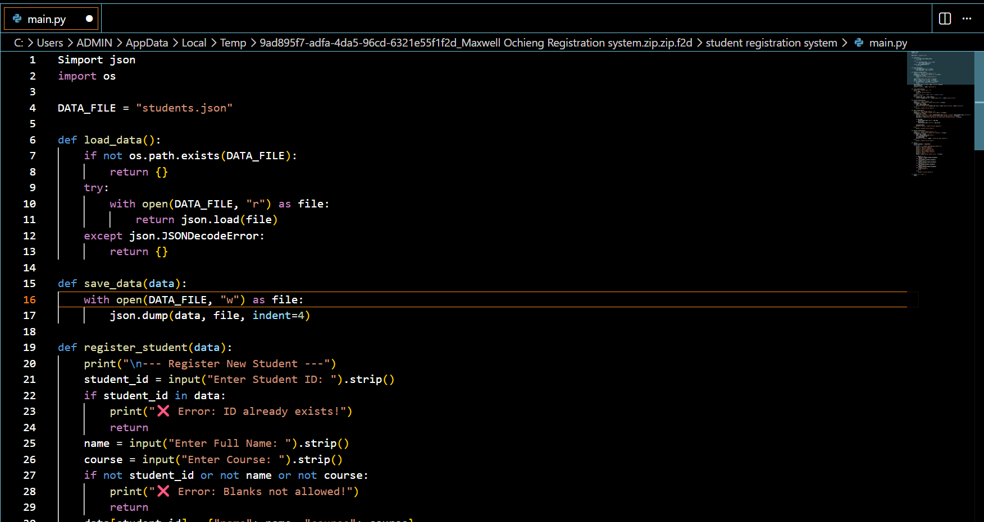
Fig 2.env file with database connection string
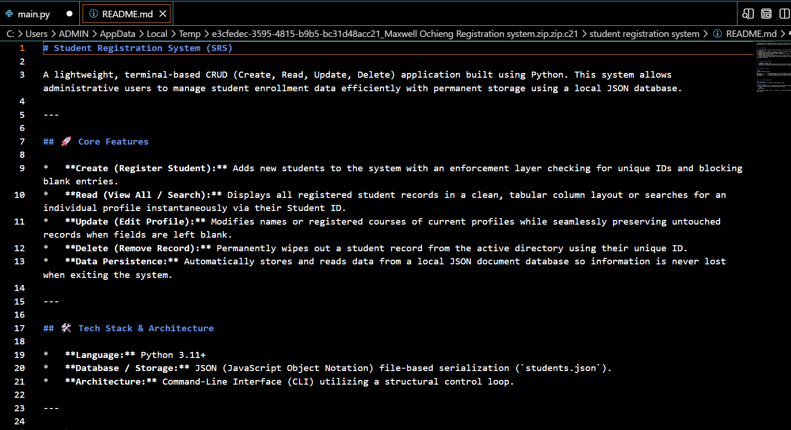

Connected successfully to the database
Fig 5: Terminal showing successful database connection

Student Reflection: Week 3 involved developing the backend using Express.js and
integrating it with MySQL using a proper connection string. I created user and tables
with proper relationships via user id. JWT authentication was implemented to meet the
requirement of not using cookies for session storage.

Week 4: Authentication System
Title: User Registration, Login and JWT Authentication
Title: Server Setup and MySQL Database Connection
During this week, I focused on the backend development of the system. I established
the connection between my PHP application and the MySQL database, ensuring that the
system could successfully communicate with the server. This phase involved configuring the
auth.php file to handle database queries and troubleshooting initial connection issues, such
as ensuring the database name in my code matched the one created in phpMyAdmin, to
allow for seamless data retrieval and storage.


Fig 1: Registration form with cryptic password hashing

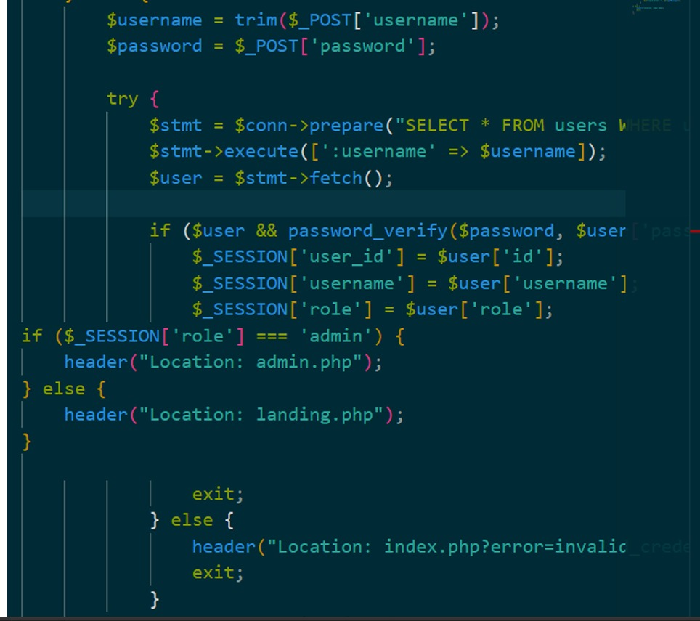
Fig 2: Login and JWT token generation

Student Reflection: In Week 4, I implemented a secure authentication system using crypts
for password hashing and JWT for token-based authentication. This approach fully complies
with the no-cookies requirement. The system ensures each user can only access.

Week 5: Crud Operations and System Extension
Title: Implementing CRUD operations and system extension
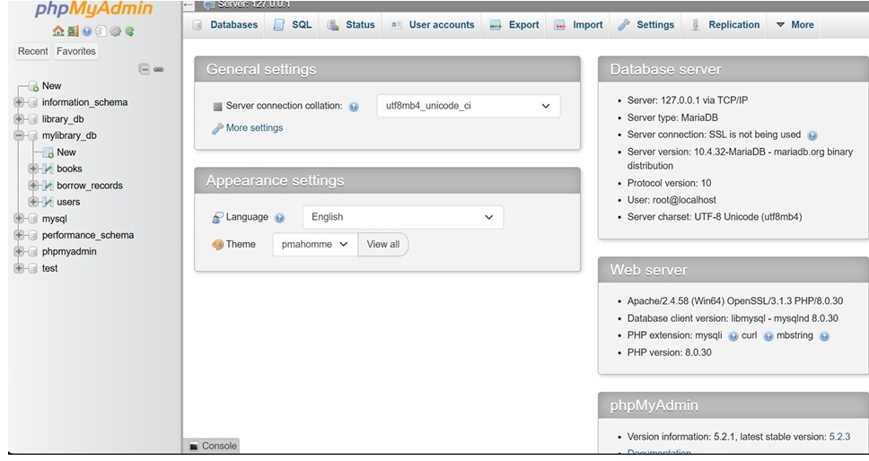
Fig 5: System Access and Workflow Initiation
Student Reflection: In Week 5, I implemented full CRUD functionality and extended the
system with secure user-specific management. Users can now register, login. All operations are protected with JWT authentication.

Week 6: Database Integration and Crud Operations
MEMO:
Structure of the database and CRUD.
CRUD stands for Create,Read,Update and Delete. These operations allow users to interact with data stored in the database.
